TASK 01:
#include<iostream>
using namespace std;

class Stack
{
int arr[6];
int top;

public:
Stack()
{
top=-1;
}

void push(int value)
{
if(top==5)
{
cout<<"Stack overflow.";
return;
}

arr[++top]=value;

}

void pop()
{
if(top==-1)
{
cout<<"Stack underflow.";
return;
}

top--;
}

void peek()
{
if(top==-1)
{
cout<<"Stack is empty ."<<endl;
}

cout<<"Current top : "<< arr[top]<<endl;
}

bool isempty()
{
return top==-1;
}

void display()
{
for(int i=top;i>=0;i--)
{
cout<<arr[i]<<" ";

}

cout<<endl;
}
};

int main()
{
Stack st;

st.push(12);
st.push(25);
st.push(17);
st.push(31);
st.push(44);
st.push(19);

st.pop();
st.peek();

st.pop();
st.peek();

st.pop();
st.peek();

st.push(52);
st.peek();

st.pop();
st.peek();

st.pop();
st.peek();

st.display();

return 0;
}
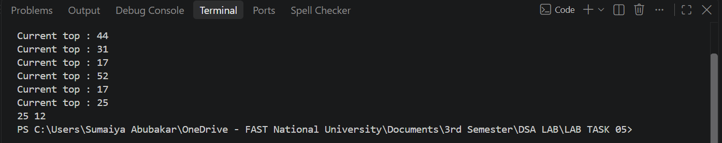

TASK 02:
#include <iostream>
#include <string>
using namespace std;

class Node

{
public:
string data;
Node *next;

Node(string word)
{
data = word;
next = nullptr;
}
};

class Stack
{
Node *top;

public:
Stack()
{
top = nullptr;
}

void push(string word)
{
Node *newNode = new Node(word);

newNode->next = top;
top = newNode;
}

void pop()
{
if (top == nullptr)
{
return;
}

Node *temp = top;
top = top->next;
delete temp;
}

string peek()
{
if (top == nullptr)
{
return "";
}

return top->data;
}

bool isEmpty()
{
return top == nullptr;
}
};

class TextEditor
{
string document;

Stack undoStack;
Stack redoStack;

public:
void type(string word)
{
if (document.empty())
{
document = word;
}
else
{
document = document + " " + word;
}

undoStack.push(word);

while (!redoStack.isEmpty())
{
redoStack.pop();
}
}

void undo()
{
if (undoStack.isEmpty())
{
return;
}

string word = undoStack.peek();
undoStack.pop();

if (document == word)
{
document = "";
}
else
{
document.erase(document.length() - word.length() - 1);
}

redoStack.push(word);
}

void redo()
{
if (redoStack.isEmpty())
{
return;
}

string word = redoStack.peek();
redoStack.pop();

if (document.empty())
{
document = word;
}
else
{
document = document + " " + word;
}

undoStack.push(word);
}

void print()
{
cout << document << endl;
}
};

int main()
{
TextEditor editor;

editor.type("Hello");
editor.print();

editor.type("World");
editor.print();

editor.undo();
editor.print();

editor.redo();
editor.print();

editor.undo();
editor.print();

editor.type("There");
editor.print();

editor.redo();
editor.print();

return 0;
}
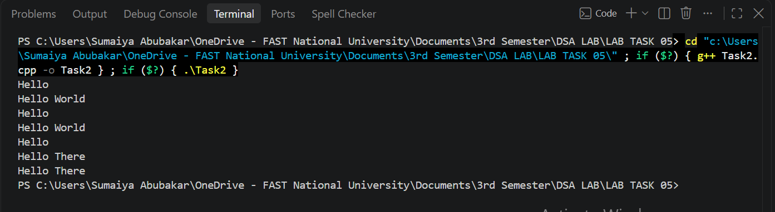

TASK 03:
#include <iostream>
using namespace std;

class Node
{
public:
int job;
Node *next;

Node(int j)
{
job = j;
next = nullptr;
}
};

class Stack
{
Node *top;

public:
Stack()
{
top = nullptr;
}

void push(int j)
{
Node *newNode = new Node(j);

newNode->next = top;
top = newNode;
}

void pop()
{
if (top == nullptr)
{
return;
}

Node *temp = top;
top = top->next;
delete temp;
}

int peek()
{
if (top == nullptr)
{
return -1;
}

return top->job;
}

bool isEmpty()
{
return top == nullptr;
}
};

class Queue
{
Node *front;
Node *rear;

public:
Queue()
{
front = rear = nullptr;
}

bool isEmpty()
{
return front == nullptr;
}

void enqueue(int j)
{
Node *newNode = new Node(j);

if (front == nullptr)
{
front = rear = newNode;
return;
}

rear->next = newNode;
rear = newNode;
}

void dequeue()
{
if (isEmpty())
{
cout << "\nQueue is empty.";
return;
}

Node *temp = front;
front = front->next;

if (front == nullptr)
{
rear = nullptr;
}

delete temp;
}

int peek()
{
if (isEmpty())
{
cout << "\nQueue is empty. ";
return -1;
}

return front->job;
}

void display()
{
if (isEmpty())
{
cout << "\nQueue is empty. ";
return;
}

Node *temp = front;
while (temp != nullptr)
{
cout << temp->job << " ";
temp = temp->next;
}

cout << endl;
}

int countsize()
{
int count = 0;

Node *temp = front;

while (temp != nullptr)
{
count++;
temp = temp->next;
}

return count;
}
};

void reverseFirstK(Queue &q, int k)
{
Stack st;
for (int i = 0; i < k; i++)
{
int temp1 = q.peek();
q.dequeue();
st.push(temp1);
}

for (int i = 0; i < k; i++)
{
int temp2 = st.peek();
st.pop();
q.enqueue(temp2);
}

int remaining = q.countsize() - k;

for (int i = 0; i < remaining; i++)
{
int temp3 = q.peek();
q.dequeue();
q.enqueue(temp3);
}
}

int main()
{
Queue q;

for(int i = 1; i <= 7; i++)
{
q.enqueue(i);
}

cout << "Original Queue: ";
q.display();

int k = 3;

reverseFirstK(q, k);

cout << "After reversing first " << k << " elements: ";
q.display();

return 0;
}
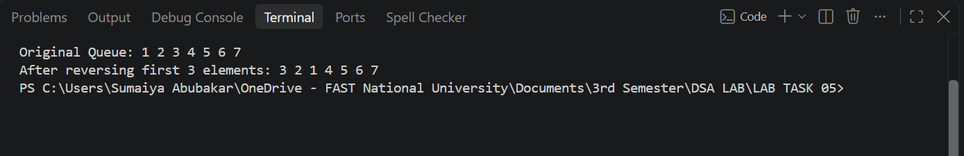

TASK 04:
#include<iostream>
using namespace std;

class Queue
{
int gateCapacity[6];
int front;
int rear;
int count;

public:
Queue()
{
front=0;
rear=-1;
count=0;
}

bool isEmpty()
{
return count==0;
}

bool isFull()
{
return count==6;
}

void enqueue(int p_ID)
{
if(isFull())
{
cout<<"\nQueue overflow.";
return;
}

rear=(rear+1)%6;
gateCapacity[rear]=p_ID;

count++;
}

int dequeue()

{
if(isEmpty())
{
cout<<"\nQueue underflow. ";
return -1;
}

int temp=gateCapacity[front];

front=(front+1)%6;

count--;

return temp;
}

void peek()
{
if(isEmpty())
{
cout<<"\nQueue is empty. ";
return;
}

cout<<"\nFront passenger ID : "<<gateCapacity[front];
}

void display()
{
if(isEmpty())
{
cout<<"\nQueue is empty. ";
return;
}

int index = front;

for(int i = 0; i < count; i++)
{
cout << gateCapacity[index] << " ";
index = (index + 1) % 6;
}

cout<<endl;
}
};

int main()
{
Queue q;
for(int i = 101; i <= 106; i++)
{
q.enqueue(i);
}

for(int i = 0; i < 3; i++)
{
cout << "Boarded: " << q.dequeue() << endl;
}

for(int i = 107; i <= 109; i++)
{
q.enqueue(i);
}

for(int i = 0; i < 2; i++)
{
cout << "Boarded: " << q.dequeue() << endl;
}

q.enqueue(110);

cout << "Boarded: " << q.dequeue() << endl;

for(int i = 111; i <= 112; i++)
{
q.enqueue(i);
}

cout << "\nFinal passengers: ";
q.display();

return 0;
}
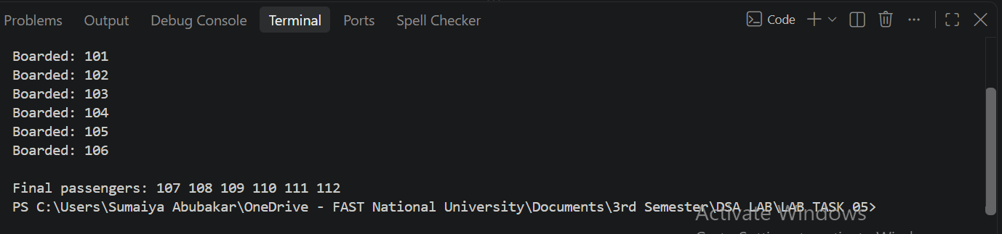

TASK 05:
#include <iostream>
using namespace std;

class Node
{
public:
char ch;
Node *next;

Node(char c)
{
ch = c;
next = nullptr;
}
};

class Stack
{
Node *top;

public:
Stack()
{
top = nullptr;
}

void push(char c)
{
Node *newNode = new Node(c);

newNode->next = top;
top = newNode;
}

void pop()
{
if (top == nullptr)
{
return;
}

Node *temp = top;
top = top->next;
delete temp;
}

int peek()
{
if (top == nullptr)
{
return -1;
}

return top->ch;
}

bool isEmpty()
{
return top == nullptr;
}

int size()
{
int count = 0;

Node *temp = top;

while (temp != nullptr)
{
count++;
temp = temp->next;
}

return count;
}
};

class MyQueue
{
Stack incomingStack;
Stack outgoingStack;

public:
void enqueue(char c)
{
incomingStack.push(c);
}

char dequeue()
{
if (outgoingStack.isEmpty())
{
while (!incomingStack.isEmpty())
{
char temp = incomingStack.peek();
incomingStack.pop();
outgoingStack.push(temp);
}
}

char temp = outgoingStack.peek();
outgoingStack.pop();

return temp;
}
};

int main()
{
MyQueue q;

q.enqueue('A');
q.enqueue('B');

cout << q.dequeue() << endl;

q.enqueue('C');

cout << q.dequeue() << endl;
cout << q.dequeue() << endl;

return 0;
}
